Ujian Akhir Praktikum - Semester Ganjil 2020/2021
Practicum Final Exam –Odd Semester Year 2020/2021
Matakuliah  Subject |  |  | COMP6153 – Operating System |  |  | 
Kelas  Class | : | BW01 / BX01 / BY01 / BZ01 |  | Tanggal Mulai  Start Date | : 22 December 2020
Kelas  Class | : |  |  | Waktu Mulai  Start Time | : 17.20
Dosen  Lecturer | : | D2518 - Rony Baskoro Lukito, S.Kom., M.Kom  D3366 - Bayu Kanigoro, S.Kom., M.T. |  | Tanggal Selesai  End Date | : 22 December 2020
Dosen  Lecturer | : |  |  | Waktu Selesai  End Time | : 19.20

PERATURAN UJIAN:
Exam Regulations:
- Mahasiswa tidak diperbolehkan berdiskusi dan/atau bekerja sama dengan peserta ujian lainnya
Student is not allowed to discuss and/or work together with other exam participants
- Mahasiswa tidak diperbolehkan untuk membuka dan menyalin dari BUKU atau CATATAN, VIDEO dari pengajar (recording kelas, VBL, Youtube, dsb) dan REFERENSI lainnya
Student isn't allowed to open and copy from any resources such as notes, videos (class recording, VBL, Youtube, etc) and other references
- Mahasiswa tidak diperbolehkan membuka dan menyalin jawaban dari internet (google, stackoverflow, dsb)
Student isn't allowed to open and copy answer from the internet (google, stackoverflow, etc)
- Asisten BERHAK memberi nilai 0 (NOL) bagi peserta ujian yang melakukan segala bentuk kecurangan
Assistant is able to give 0 (ZERO) score for exam participant who does any cheating actions
- Kumpulkan jawaban tepat pada waktunya, apabila terlambat mengumpulkan maka jawaban tidak akan dikoreksi dan nilai mahasiswa adalah 0
Submit the answer on time, if not, then the answer will not be checked, and the students will receive 0 (ZERO)
- Bila Anda tidak membaca peraturan ini, maka Anda dianggap telah membaca dan menyetujuinya
If you have missed to read these regulations, so you are considered to have read and agreed on it



SOFTWARE YANG DIGUNAKAN:
Software will be used:
- Java 8
- Eclipse 2020.6
- NachOS 5.0j

FILE YANG DIKUMPULKAN:
File must be collected:
- JAVA
- CLASS

PERHATIAN!
Attention!
- Bagi yang mengerjakan tidak sesuai dengan soal, maka akan diberikan nilai NOL (0)
For those who do not work in accordance with the exam case will be marked as ZERO (0)
- Bagi yang mengerjakan tidak sesuai dengan software dan versi yang telah ditetapkan, maka akan tetap dikoreksi dengan software dan versi yang telah ditetapkan
For those who do not work in accordance with the software and specific version will be corrected by the predefined software and version
- Kompres semua jawaban yang akan diunggah. Pastikan format pengumpulan nama file dan ekstensi sesuai dengan format berikut: [NIM]-[NAMA].zip
Compress all file that will be uploaded. Make sure the format for collecting file name and extension according to the following format: [NIM]-[NAME].zip

Soal
Case

Important Notes:
- Use your own Console and Scheduler (FIFO)
- You must use Semaphore to control operation
- You must use Timer to generate tick of time
- Use KThread

Watch Service
Mrs. Lala is the owner of a watch store that sells high quality original watch across the country. As the owner, she needs an application that helps her manage services for her shop by storing them in a file with the help of file system. The application she wanted will be used to manage booked service(s), such as to save, view, remove or add new service(s). As a programmer, you are being asked to create the application using nachOS in Java Programming Language.
The application will look for a file named “Service.txt” at the start point. If the file existed, the application would load the file with the help of file system. The system will then convert the existing data into an acceptable service format and proceed to store them into the system. Otherwise, create a new empty file with the said name.
The application will then continue into the main menu where user will be shown data stored in the list along with the choices that represent features of the application which are:
- Add Service
- View Service(s)
- Delete Service
- Clear All & Exit
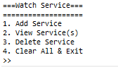
Figure 1. Main menu
- Add Service
The first option of the menu allows user to add a new service into the list. User will be required to fill in the needed data which are listed below:
- Ask user to input customer name. Customer name must be between 3 and 30 characters.
Figure 2. Customer name input
- Ask user to input service type. Service type must be between “Change Battery”, “Clean & Polish”, or “Repair” (case sensitive).
Figure 3. Service type
- Ask user to input watch’s brand. Watch’s brand must be between “Rolex”, “Guess”, or “Seiko” (case insensitive).
Figure 4. Watch brand
- After all the required input has been filled, save the input file named “Service.txt” with the following format and show success message to the user.
[Customer Name]#[Service type]#[Brand]

Figure 5. Success message

- View Service(s)
The second option of the menu allows the user to view all data read by file system. The process follows the following steps which are:
- Check if item list has any data. If the service list didn’t have any data, the application shows an error message to the user.
Figure 6. View validation
- Otherwise, if the service list already filled or have list of service, the application will show all files received using KThread and Scheduler (FIFO Concept). The item will be shown with delay 500 miliseconds (using Thread sleep).
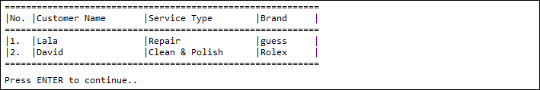
Figure 7. View all data

- Delete Service
The third option of the menu allow user to remove an existing service from the list. The process runs through the following steps:
- Check if item list has any data. If the service list didn’t have any data, the application shows an error message to the user.
Figure 8. Delete validation
- Otherwise, the application will show the existing service in the list and proceed to wait for user to input the service number which want to be deleted. The user input must be validated with the condition of service number must be between 1 and the list count of services.
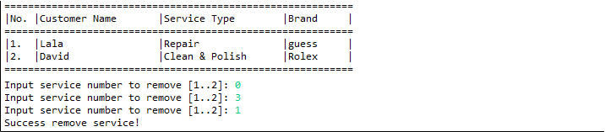
Figure 9. Delete index

- Clear All & Exit
If the user chooses the fourth Menu (Clear All & Exit), the application will Clear All Data in file named “Service.txt” and print the time in second(s) using a timer.
Figure 10. Exit message

